RS-PH-N01-3 Integrated PH Transmitter User Manual
(Type 485)

Document version:V1.2

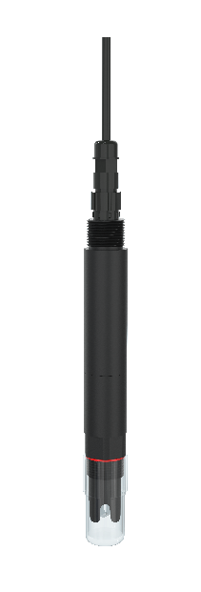

Catalog

1. Product description 4
1.1 Features 4
1.2 Equipment technical parameters 4
1.3 Product model 5
1.4 Product List 5
1.5 Equipment size and installation 5
2. Equipment Instructions 6
2.1 Wiring Instructions 6
2.2 Parameter configuration description 6
2.3 Electrode Calibration Instructions 7
2.4 Mod Bus Communication and register details 9
3. Precautions and maintenance 12
4. Document history 14

Product description

This product is a device for measuring the PH value of solution (hydrogen ion concentration index, PH value), with automatic temperature compensation function, automatic temperature compensation and manual temperature compensation can be switched at will. This product adopts an integrated design, the structure is lighter and simpler, and the use is more convenient. Waterproof grade IP68. This product is suitable for industrial sewage, domestic sewage, agriculture, aquaculture and other scenarios in a non-corrosive weak acid and weak alkali environment.

1.1 Features
- PH measurement range 0~14PH, resolution 0.01PH.
- The temperature measurement range is 0~60℃, and the resolution is 0.1℃.
- One-piece design, light and simple structure, easy to use.
- The reference adopts double salt bridge design, which has stronger anti-pollution ability.
- Waterproof grade IP68.
- With automatic temperature compensation function, manual compensation and automatic compensation can be switched at will.
- RS485 communication interface: MODBUS-RTU communication protocol can be easily connected to the computer for monitoring and communication.
- ModBus communication address can be set, baud rate can be modified.
- The equipment adopts wide voltage power supply DC 7~30V can be used.

1.2 Equipment technical parameters
Power supply | DC 7~30V
Power consumption | 0.3W
Communication Interface | RS485; standard MODBUS-RTU protocol; communication baud rate: default 4800 (1200, 2400, 4800, 9600, 19200, 38400, 57600, 115200 can be set)
PH measurement range | 0~14.00PH ; Resolution: 0.01PH
PH measurement error | ±0.15PH
Repeatability error | ±0.02PH
Temperature measurement range | 0~60℃; Resolution: 0.1℃  (It is the set temperature when do manual temperature compensation, the default is 25°C)
Temperature measurement error | ±0.5℃
Equipment working conditions | Environment temperature: 0-60℃
Waterproof level | IP68
Pressure resistance | 0.6MPa
Line length | Default 5m (other lengths can be customized)
Electrode life cycle | 6~12 months

Data measured by Renke Laboratory

1.3 Product model
RS- |  |  |  |  | company code
 | PH- |  |  |  | Industrial PH Transmitter
 |  | N01- |  |  | RS485 (Modbus-RTU protocol)
 |  |  | 3 |  | One-piece housing
 |  |  |  | 201T | Conventional composite electrode
 |  |  |  | 202T | Planar desulfurization electrode
 |  |  |  | 204T | Plating electrode
 |  |  |  | 206T | Antimony electrode

1.4 Product List
◆1 integrated PH transmitter
◆5m (or customized length) cable
◆Certificate of conformation, Warranty Card, etc.

1.5 Equipment size and installation

1.5.1 Equipment size

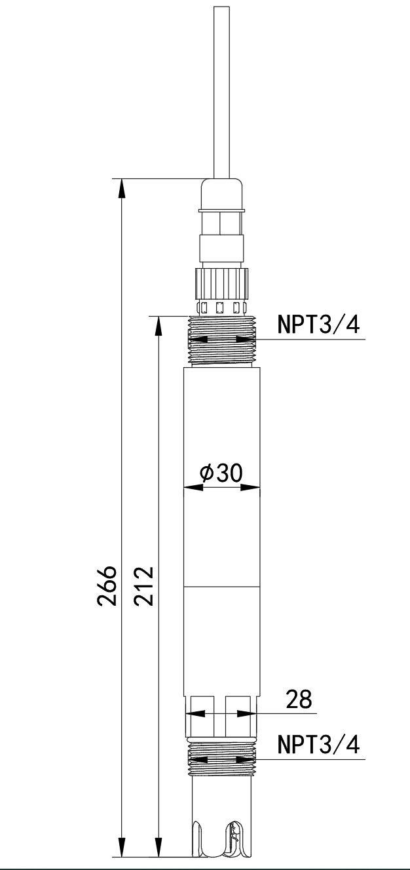

1.5.2 Device installation
1. Submerged installation: The lead wire of the equipment is passed through the waterproof pipe, and the 3/4 thread on the top of the equipment is connected with the 3/4 thread of the waterproof pipe with raw material tape. Make sure that the top of the equipment and the equipment lines are free of water.
2. Pipe Installation: Connect to the pipe through the 3/4 thread of the device.
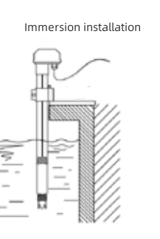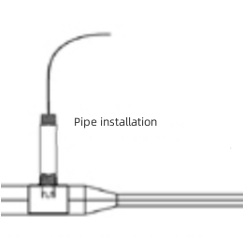

Equipment Instructions

2.1 Wiring Instructions
 | Wire color | Illustrate
Power supply | brown | V+（7~30V DC）
Power supply | black | V-
Communication | yellow | 485-A
Communication | blue | 485-B

2.2 Parameter configuration description
Open the data package, select "Debugging Software"---"485 Parameter Configuration Software", find 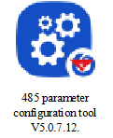 and just open it.
- Select the correct COM port (check the COM port in "My Computer - Properties - Device Manager - Port"), the following figure lists the driver names of several different 485 converters.
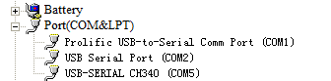
2) Connect only one device and power it on, click the test baud rate of the software, the software will test the baud rate and address of the current device, the default baud rate is 4800bit/s, and the default address is 0x01.
3) Modify the address and baud rate according to the needs of use, and at the same time, you can query the current functional status of the device.
4) If the test is unsuccessful, please re-check the equipment wiring and 485 driver installation.
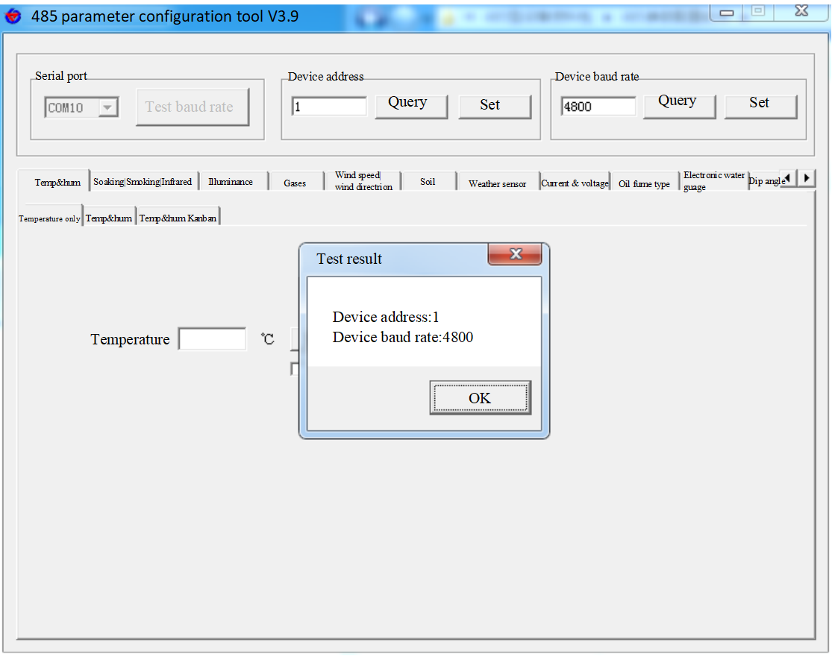

2.3 Electrode Calibration Instructions
1) Prepare two standard buffer solutions with different PH. If measuring acidic solution, use standard buffer solution of 4.01 and 6.86, if measuring alkaline solution, use standard buffer solution of 6.86 and 9.18, and use standard buffer solution of 4.01 and 9.18 if it is general. Standard buffer.
2) Open the configuration software .

3) Select the corresponding serial port number, select the correct device address (the default address is 1) and the baud rate (the default baud rate is 4800), then open the serial port, find the PH tab, and check the automatic option.
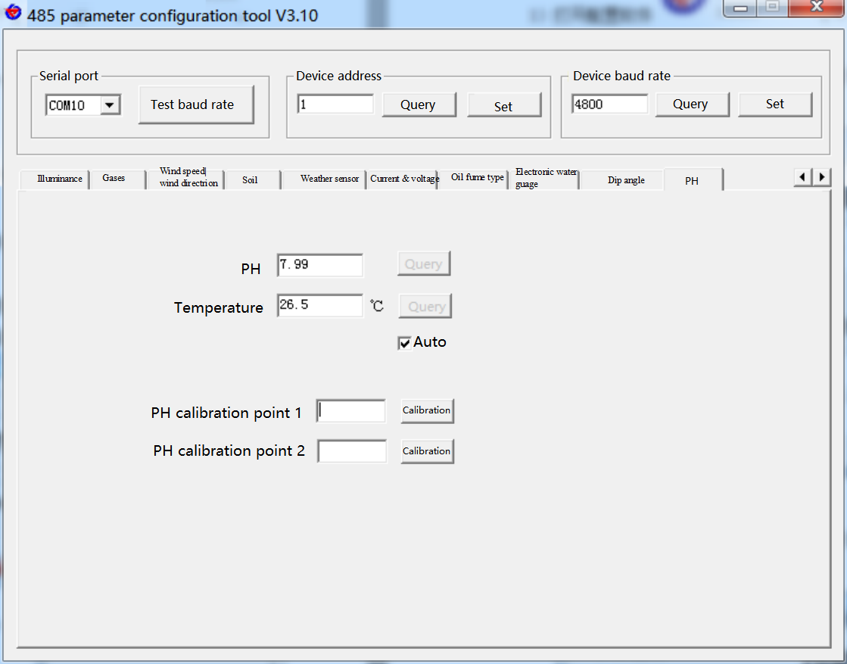
4) Put the PH electrode into a standard buffer solution with a relatively small PH value at room temperature (about 25°C) (for example, choose 4.01 when using 4.01 and 9.18 buffers), and input the standard buffer solution PH value at the calibration point 1, cancel automatic after the value is stable, click "Calibration" of calibration point 1 to calibrate the first point.
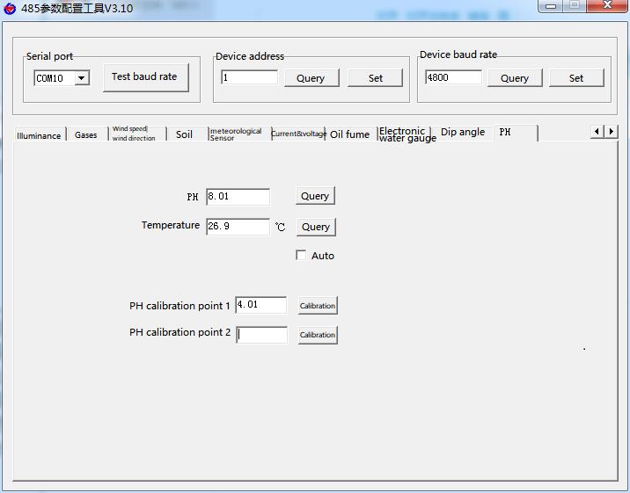
- After the calibration of the first point is completed, clean the PH electrode and use a paper towel or soft cloth to absorb excess water (do not damage the electrode glass bulb, otherwise the electrode will be failed), re-check the automatic option, and put in the standard buffer solution which the PH value relatively large (for example, choose 9.18 when using 4.01 and 9.18 buffers), and input the standard buffer solution PH value at the calibration point 2, cancel the automatic when the value is stable, and click "Calibration" at the second calibration point to calibrate Second point. Calibration is complete.
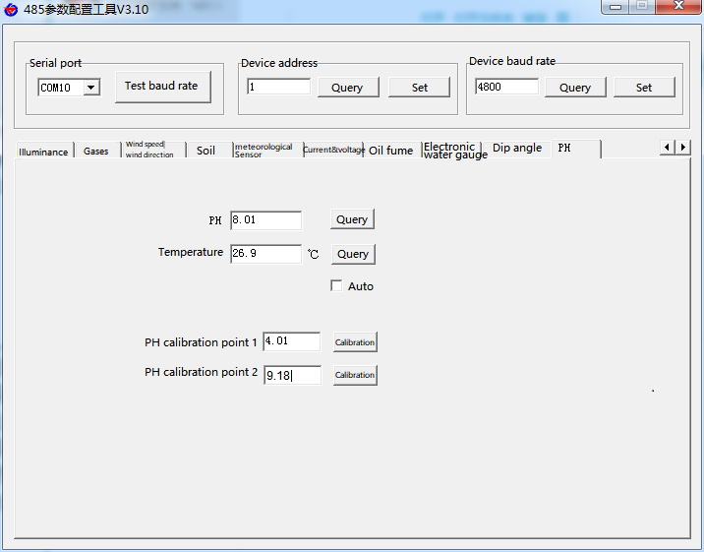

2.4 Mod Bus Communication and register details

2.4.1 Device Communication Basic Parameters
Encode | 8 bit binary
Data bits | 8 bits
Parity bit | none
Stop bit | 1 bit
Error checking | CRC (Redundant Cyclic Code)
Baud rate | Factory default is 4800bit/s

2.4.2 Data Frame Format Definition
Adopt Modbus-RTU communication protocol, the format is as follows:
Initial structure ≥4 bytes of time
Address code = 1 byte
Function code = 1 byte
Data area = N bytes
Error check = 16-bit CRC code
Time to end structure ≥ 4 bytes of time
Address code: It is the address of the transmitter, which is unique in the communication network (factory default 0x01).
Function code: the function instruction of the command sent by the host.
Data area: The data area is the specific communication data, please note that the 16bits data high byte are in front!
CRC code: two-byte check code.
2.4.3 Register address
Register address | PLC address | Support function code | Illustrate
0x0000 | 40001 | 0x03/0x04 | PH value (16-bit unsigned integer, 100 times the actual value)
0x0001 | 40002 | 0x03/0x04 | temperature (16-bit signed integer, 10 times the actual value)
0x0050 | 40081 | 0x03/0x04/0x06 | PH deviation value (16-bit signed integer, 100 times the actual value)
0x0051 | 40082 | 0x03/0x04/0x06 | Temperature deviation value (16-bit signed integer, 10 times the actual value)
0x0060 | 40097 | 0x03/0x04/0x06 | Whether to manually compensate (1: yes 0: no)
0x0061 | 40098 | 0x03/0x04/0x06 | Manual compensation for temperature (16-bit signed integer, 10 times the actual value)
0x0120, 0x0121 | 40289, 40290 | 0x10 | Electrode calibration (two registers are used in conjunction)
0x07D0 | 42001 | 0x03/0x04/0x06/0x10 | 1~254 (16-bit unsigned integer, factory default 1)
0x07D1 | 42002 | 0x03/0x04/0x06/0x10 | 0 for 2400  1 for 4800  2 for 9600  3 for 19200  4 for 38400  5 for 57600  6 for 115200  7 for 1200

2.4.4 Communication protocol example and explanation
Example 1: Read the current PH and temperature of the device with address 01
Delivery frame:
Address code | Function code | Register address | Register content | Check code low bit | Check code high bit
0x01 | 0x03 | 0x00 0x00 | 0x00 0x02 | 0xc4 | 0x0b
Response frame: (For example,the read PH value is 7.90, temperature value is 26.5°C)
Address code | Function code | Number of valid bytes | Register content | Check code low bit | Check code high bit
0x01 | 0x03 | 0x04 | 0x03 0x16 0x01 0x09 | 0xb8 | 0xbe
PH calculation: 316H (hex)=790 => PH=7.90
Temperature calculation: 109H (hexadecimal)=265=>temperature=26.5℃
Example 2: Set the deviation value for the current PH value of device whose address is 01, to correct the PH value.
Delivery frame: (if the current device output PH is 7.90, the value should be corrected to 8.00, the difference is 8.00-7.90=0.10, enlarge it 100 times to 10=>0xa (hexadecimal), and the register content is written 00 0a)
Address code | Function code | Register address | Register content | Check code low bit | Check code high bit
0x01 | 0x06 | 0x00 0x50 | 0x00 0x0a | 0x09 | 0xdc
Response frame: (according to the MODBUS standard, the response is a mirrored message of the delivery frame)
Address code | Function code | Register address | Register content | Check code low bit | Check code high bit
0x01 | 0x06 | 0x00 0x50 | 0x00 0x0a | 0x09 | 0xdc

2.4.5 Register calibration electrode
If the electrode needs to be calibrated, it can be calibrated by writing parameters to the 0x0120 and 0x0121 registers through the 0x10 function code. This equipment adopts two-point calibration, and two known PH standard solutions need to be prepared. When calibrating the first point, write 0x0001 to the 0x0120 register, and write 100 times the standard PH value of the first point to the 0x0121 register; when calibrating the second point, write 0x0002 to the 0x0120 register, and write100 times the standard PH value of the second point to the 0x0121 register. Calibration is complete.
Example: Select the 4.01 PH standard solution to calibrate the first point.
Delivery frame: 4.01*100=401 converted to 16 hexadecimal is 0x191
Address code | Function code | Register address | Register length | Length in bytes | Register content | Check code low bit | Check code high bit
0x01 | 0x10 | 0x01 0x20 | 0x00 0x02 | 0x04 | 0x00 0x01 0x01 0x91 | 0x6d | 0xdb
Response frame: (according to the MODBUS standard, the response is a mirrored message of the delivered frame)
Address code | Function code | Register address | Register length | Check code low bit | Check code high bit
0x01 | 0x10 | 0x01 0x20 | 0x00 0x02 | 0x41 | 0xfe
Then select the 9.18 PH standard solution, and calibrate the second point.
Delivery frame: 9.18*100=918 converted to 16 hexadecimal is 0x396
Address code | Function code | Register address | Register length | Length in bytes | Register content | Check code low bit | Check code high bit
0x01 | 0x10 | 0x01 0x20 | 0x00 0x02 | 0x04 | 0x00 0x02 0x03 0x96 | 0xdd | 0x79
Response frame: (according to the MODBUS standard, the response is a mirrored message of the delivered frame)
Address code | Function code | Register address | Register length | Check code low bit | Check code high bit
0x01 | 0x10 | 0x01 0x20 | 0x00 0x02 | 0x41 | 0xfe

3. Precautions and maintenance
- The equipment itself generally does not require daily maintenance. When there is an obvious failure, please do not open it to repair it by yourself, please contact us as soon as possible!
- There is an appropriate amount of soaking solution in the protective bottle at the front of the electrode, let the electrode tip soaked in it to keep the glass bulb and the liquid junction activated. When measuring, unscrew the bottle cap, pull out the electrode, and wash it with pure water before use.
- Preparation of electrode soaking solution : Take a bag of PH4.00 buffer agent, dissolve it in 250 ml pure water, add 56 grams of analytical pure potassium chloride, heat it properly in an electric furnace, and stir until it is completely dissolved. It can also be soaked in 3.3M potassium chloride solution, and the preparation is as follows: Dissolve 25 grams of analytically pure potassium chloride in 100 ml of pure water.
- The glass bulb at the front of the electrode should not be contacted with hard objects, any damage and rubbing will make the electrode ineffective.
- Before measurement, the bubbles in the electrode glass bulb should be shaken off, otherwise it will affect the measurement. During the measurement, stirring the electrode in the solution under measurement and then standing, to speed up the response.
- Deionized water should be used to clean the electrode before and after measurement to ensure accuracy.
- The PH electrode will be passivated after long-term use. The phenomenon is that the sensitivity gradient is reduced, the response is slow, and the reading is inaccurate. For the non-metal electrode: Dip the bulb at bottom electrode in the 0.1M dilute hydrochloric acid for 24 hours(0.1M dilute hydrochloric acid preparation:9ml hydrochloric acid dilute with distilled water to 1000ml), then use 3.3M potassium chloride solution to soaking it for 24 hours. If the PH electrode be passivated seriously and soaking with 0.1M hydrochloric acid has no effect, the bulb end of the PH electrode can be soaked in 4% HF (hydrofluoric acid) for 3-5 seconds, washed with pure water, and then soaked in 3.3M potassium chloride solution for 24 hours to restore performance. For antimony electrodes: the metal head can be polished with fine sandpaper until it appears metallic luster, to restore its performance.
- The contamination of the glass bulb or the blockage of the liquid junction will also passivate the electrode. At this time, it should be cleaned with an appropriate solution according to the nature of the contaminant, as shown in the table below (for reference).

Pollutants:
Inorganic metal oxides
Organic oils
Resin macromolecular substance
Protein blood precipitate
Pigment substances
Cleaner:
Less than 1M dilute acid
Dilute detergent (weak alkaline)
Alcohol, acetone, ether
Acid enzyme solution
Dilute Bleach, Hydrogen Peroxide

- The electrode life cycle is about 6~12 months, and the new electrode should be replaced in time after aging.
- The equipment should be calibrated before each use. It is recommended to calibrate every 3 months for long-term use. The calibration frequency should be adjusted according to different application conditions (the degree of dirt in the application, the deposition of chemical substances, etc.).

4. Document history
V1.0 Document establishment
V1.1 Add new model selection
V1.2 Change the electrode life cycle

